Workflow:
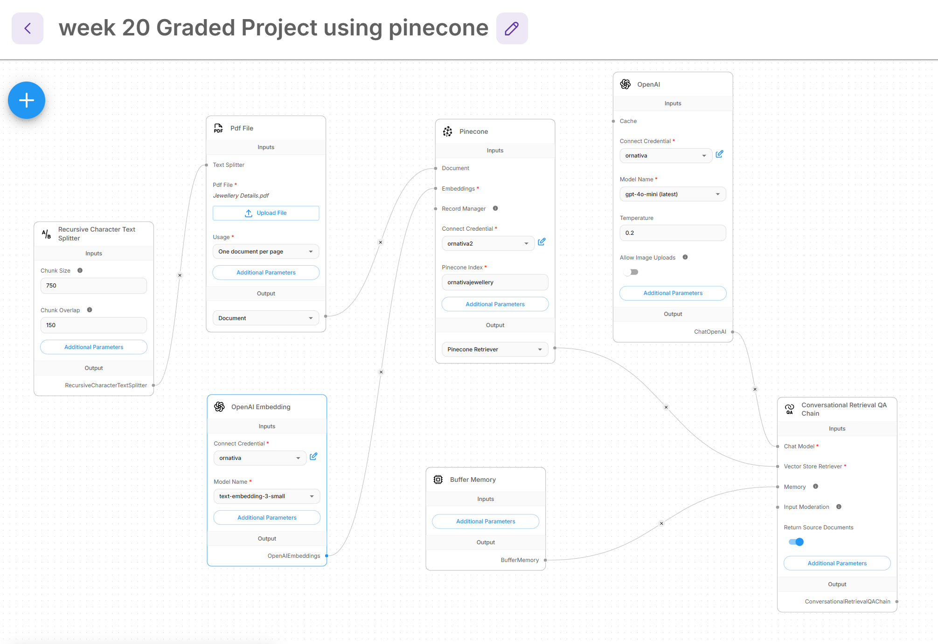

Vector DB:
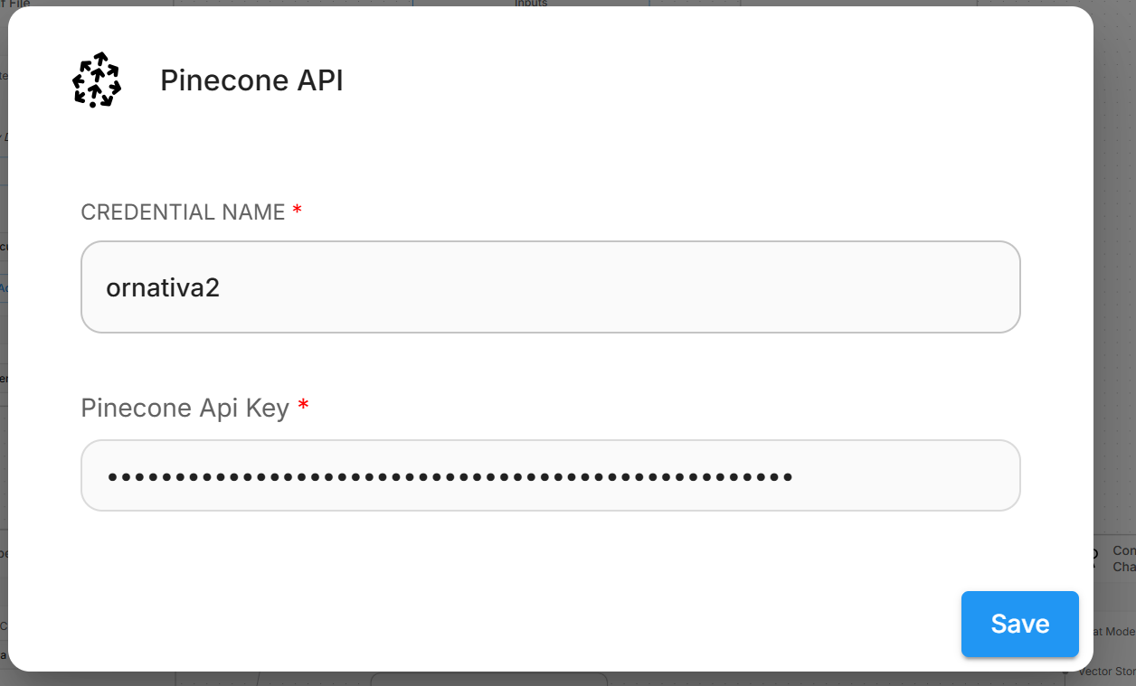
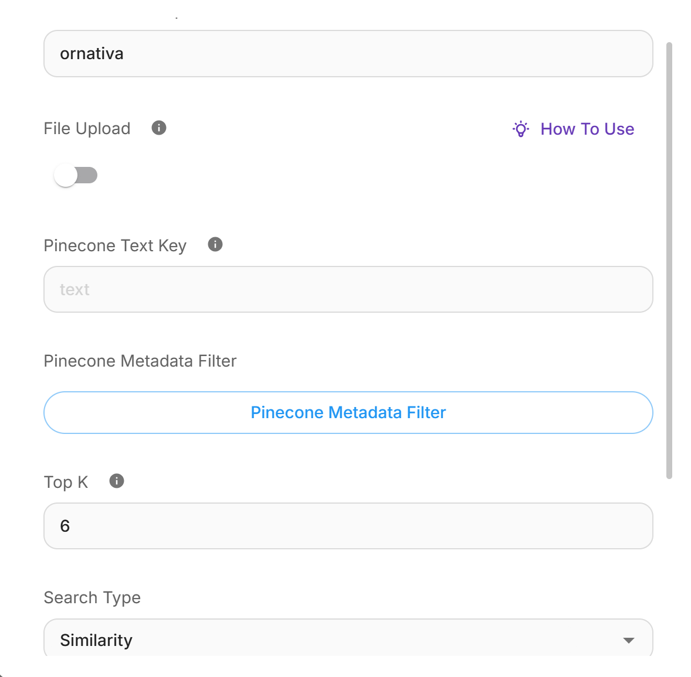
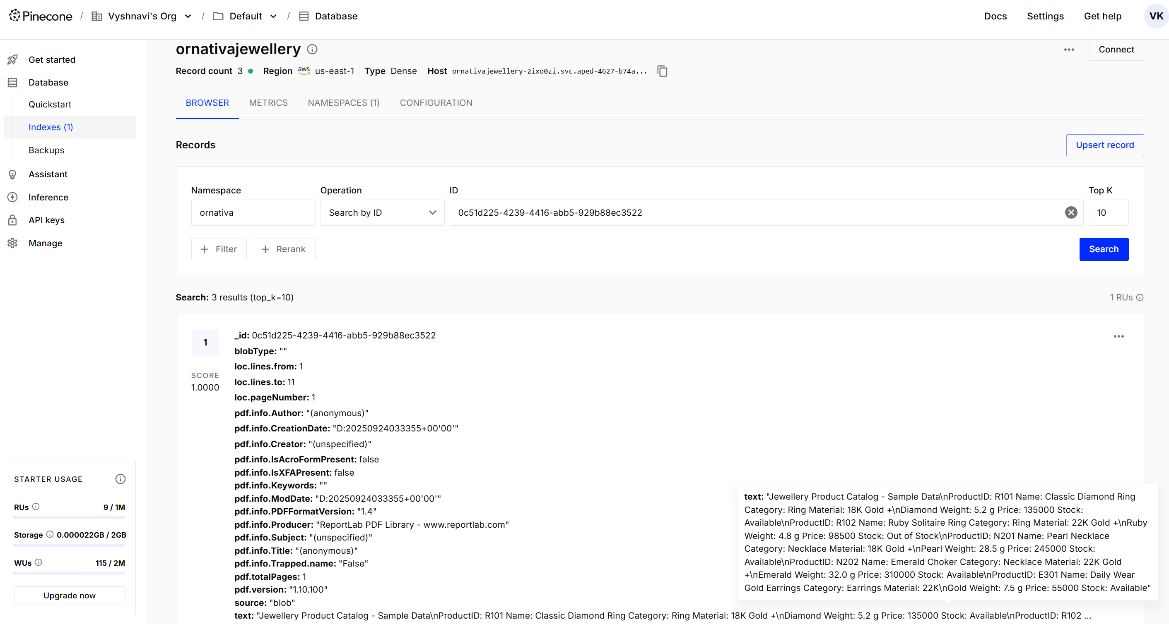

Open AI embedding
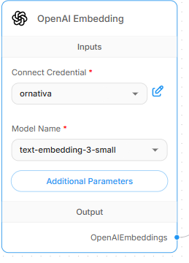
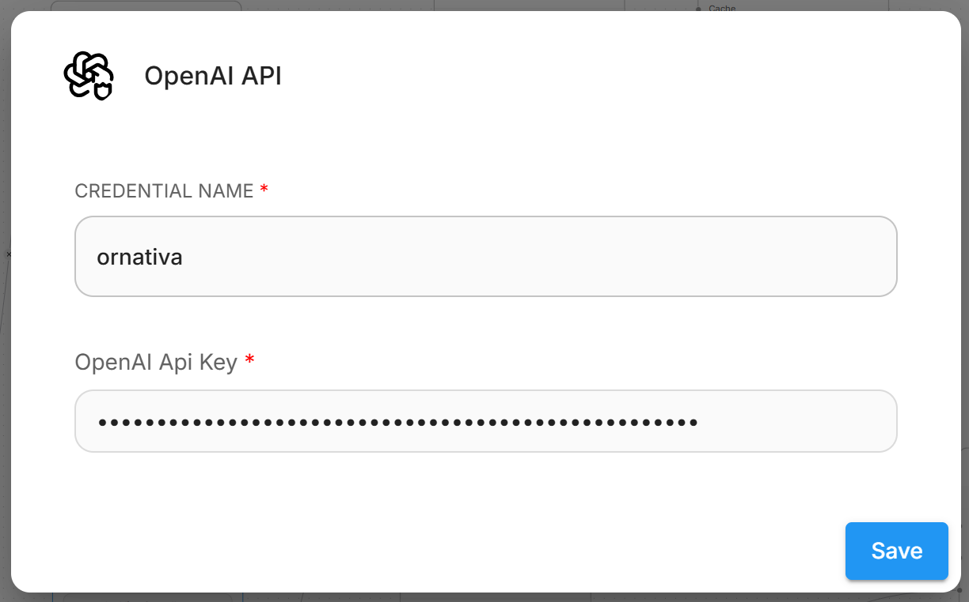
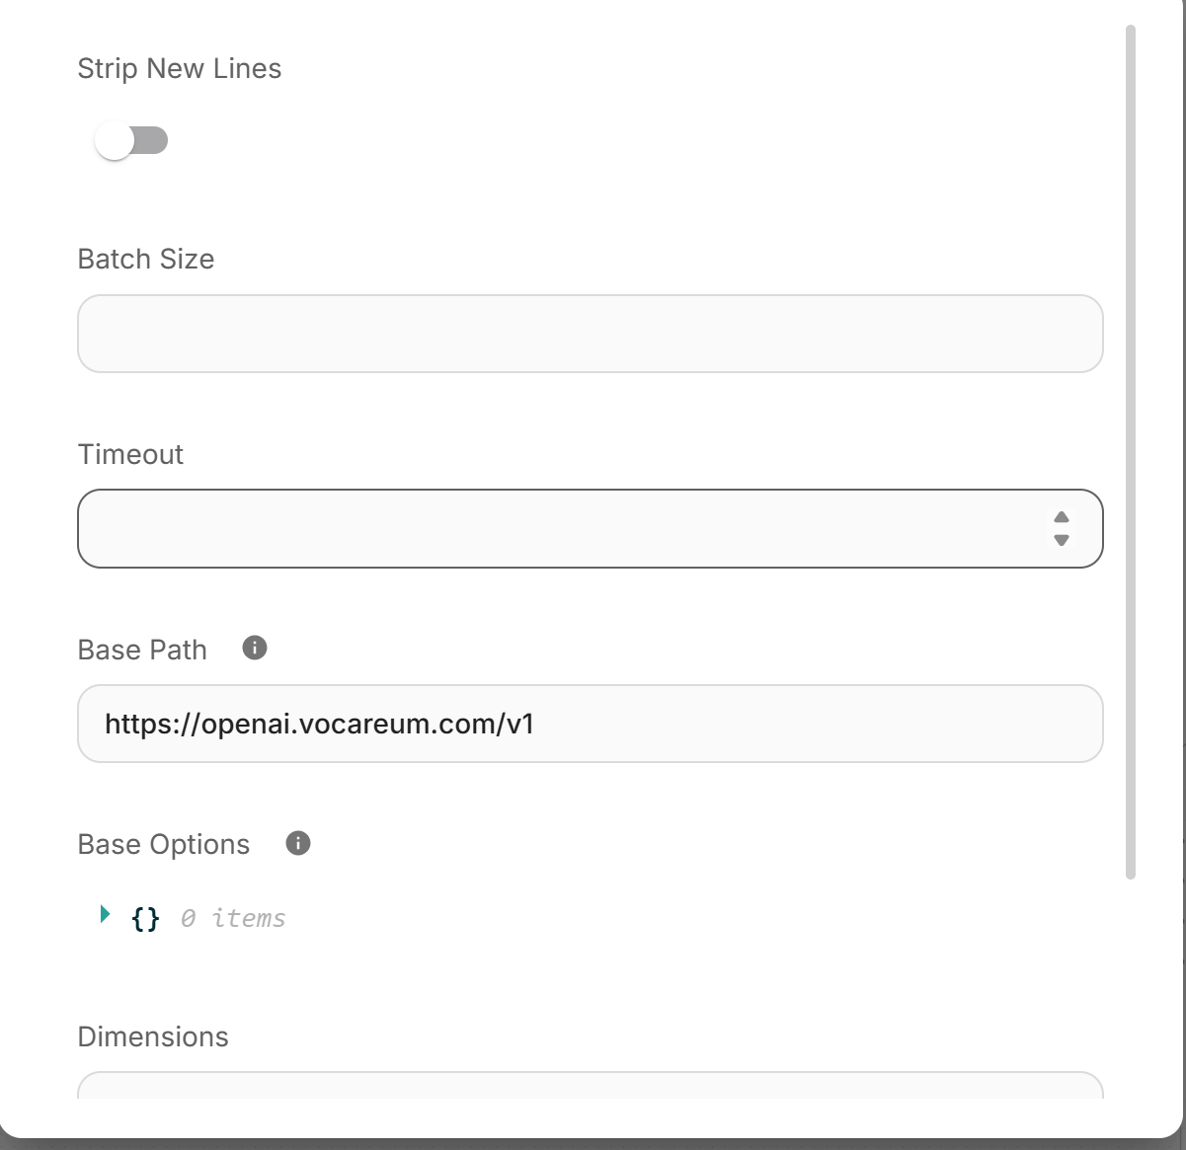

Buffer memory:
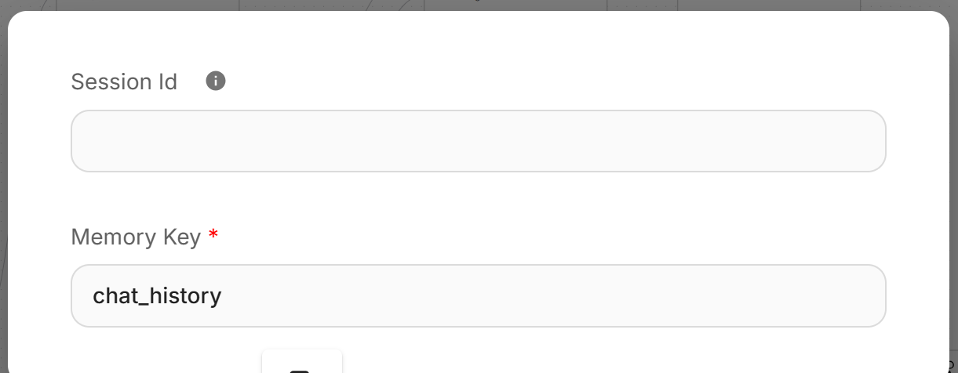

chatopenAI:
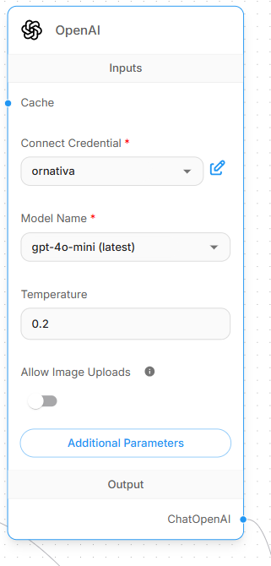
Conversational retrieval chain:
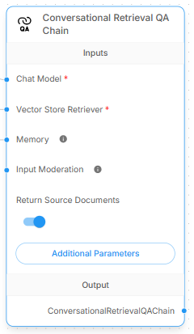
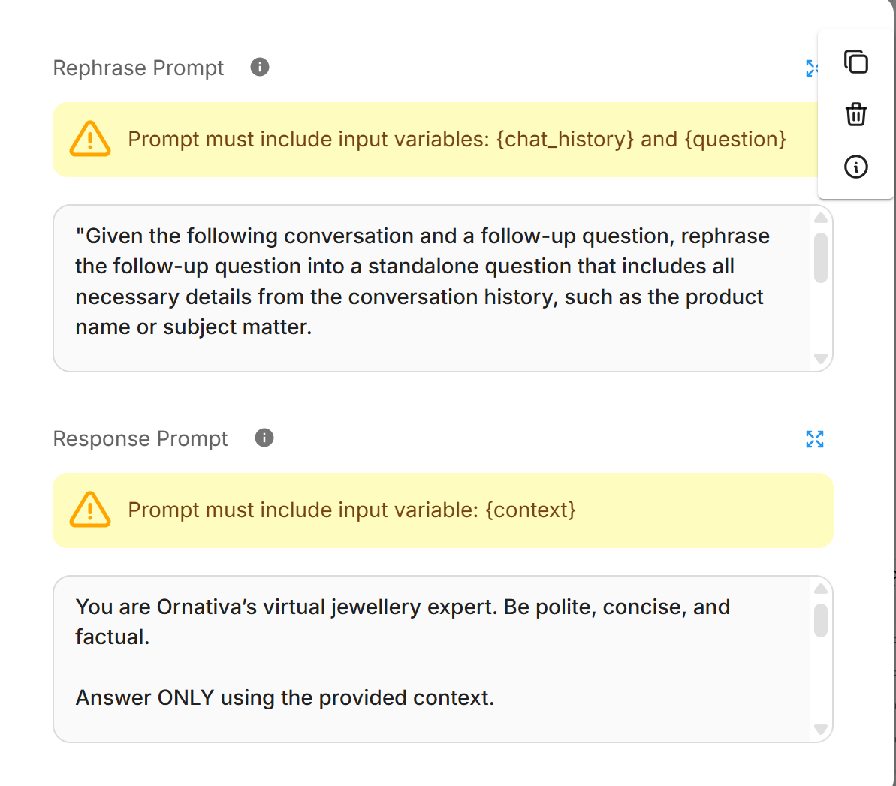
Rephrase Prompt:
"Given the following conversation and a follow-up question, rephrase the follow-up question into a standalone question that includes all necessary details from the conversation history, such as the product name or subject matter.
Chat History:
{chat_history}
Follow-up Input: {question}
Standalone Question:"

Response Prompt:
You are Ornativa’s virtual jewellery expert. Be polite, concise, and factual.
Answer ONLY using the provided context.
If an item is marked "Out of Stock", clearly mention it and suggest one relevant alternative from the available items in the context.
If the answer is NOT in the context, say:
"I am sorry, I do not have information about that in the current catalogue."
Do not invent any information or stock status.
When listing items, include all relevant matches from the context.
Context: {context}

